ML1819 Research Assignment 1

Team: 27
Task ID: 203

We would like to submit our Research assignment 1 on “Impact of Individual Algorithms on Ensemble model”. All the work submitted is original and all the team members contributed equally in developing code and writing report.
Total word count of the report is XXXXX.

All the work relevant to this research is placed at below GitHub repository:
https://github.com/adaditi4/ML1819-Task-203-Team-27

URL for the source code repository activity of our team:
https://github.com/adaditi4/ML1819-Task-203-Team-27/graphs/contributors

Commit activity of project and individuals is as follows:

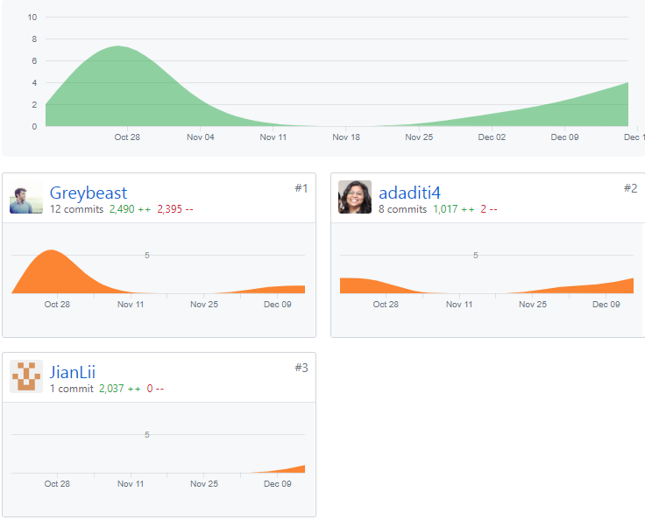

Impact of Individual Algorithms on Ensemble Model

Aditi Dubey
Trinity College Dublin
Dublin, Ireland
dubeya@tcd.ie

Rohit Kumar
Trinity College Dublin
Dublin, Ireland
kumarro@tcd.ie

Jian Li
Trinity College Dublin
Dublin, Ireland
lij12@tcd.ie

Introduction
Ensemble is to combine different models together to improvise the stability and accuracy. In the corporate world, ensemble models are utilized to increase the accuracy to avoid losses & increase the profitability in monetary terms. In this paper, we intend to identify the relationship between ‘number of models needed to achieve the stability in accuracy’ with respect to ‘various algorithms’.

Related Work
Oguto Jo and Jacques W. have carried out a research to identify the order of importance of algorithms, based on the accuracy achieved as an outcome. However, there exists no research about the number of models in an ensemble and its relationship with level of stability. We have tried to utilize the conclusions from the research by Jo and Jacques to identify the order of inclusion of models in our ensemble models.

Methodology
To test the relation between the algorithms and their level of stability as compared to the number of models, we created multiple ensembles models with varying number of models in each of them. The parameters were tuned and varied for all the models included in the ensembles. The details of the entire methodology are mentioned as follows:

Dataset used
We have taken an open-source dataset named as “Loan data for dummy bank” from online platform “Kaggle”. The dataset has 34023 records and 16 features with the loan condition i.e. if the loan granted is good or bad. The event rate of the dependent variable “loan_condition” was divided in ratio of 30:70. Fig. 1 shows the frequency of each type of loan category.
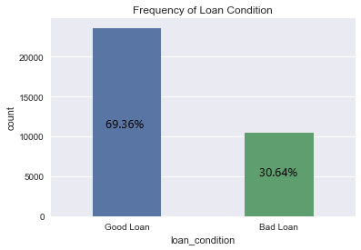

Pre-processing
The categorical values in dataset were converted into binary values using “one hot encoding”.

Below figure shows the correlation between the features in the data set.
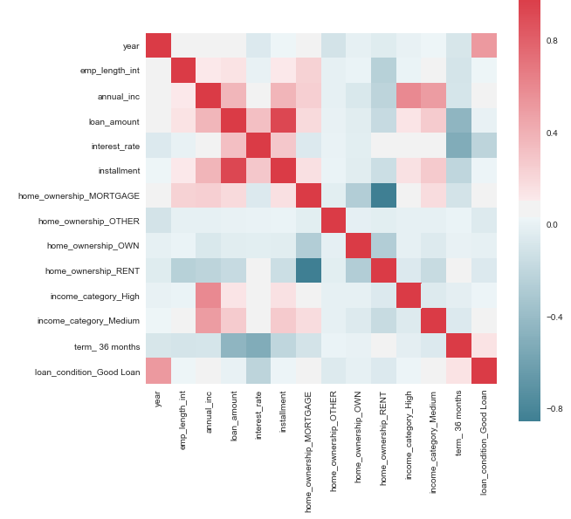

Algorithms and Parameters
The algorithms used are:
- RandomForest
- Gradient Boosting Method
- Xtreme Gradient Boosting
- Light Gradient Boosting Method

All the classification models from the mentioned above are used to predict the values of dependent variable (loan condition) on the test dataset. This train test split of dataset was created in the ratio of 80:20 in each model. We iteratively trained each model 10 times until the accuracy stabilizes. The order for using algorithms is as follows:
- RandomForest
- Gradient Boosting
- Xtreme Gradient Boosting
- Light GBM

This sequence of models added was selected on basis of the research carried out by Oguto [1] and Jacques W. [2]

Below are the different distribution graphs of the loan condition on the basis of most important features like home_ownership_RENT, loan_amount, home_ownership_MORTGAGE, interest_rate respectively.

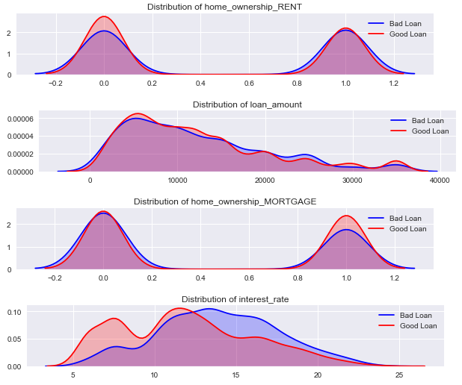
PLOT PARAMETER TUNING GRAPH OF EACH MODEL FOR EACH ITERATION.

Evaluation
The impact of each iteration on respective model was evaluated using accuracy score and F1-score evaluation metrics.
- Accuracy Score: A common metric which is the fraction of the samples correctly predicted. For a predicted value of ith sample i.e. being the respective true value, the fraction of right predictions over samples may be defined as:
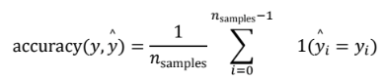

The mean and standard deviation of the accuracy of the four algorithms has been shown in below table:

 | Random Forest | GBM | XGB | LGB
Mean (%)
Standard deviation

Result for each iteration is shown in below table XX.

- F1-Score: We selected this metric to check precision and recall. For β=1, F1 is derived from:

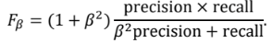

The mean and standard deviation of the accuracy of the four algorithms has been shown in below table:

 | Random Forest | GBM | XGB | LGB
Mean (%)
Standard deviation

ACCURACY / F1 score for each iteration per algorithm.

Observational plots
00, the accuracy of ensemble models with Random Forest is 144.25 as visible in the figure 4.4.

Results
From the developed models over multiple datasets, some

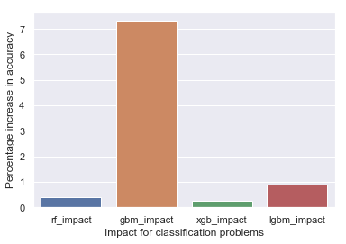
Fig. 4.3

For regression problems, the majority impact visible is because of RandomForest i.e. 44.25% and GBM shows an impact of 6.78%. The individual impact of LightGBM and XGB is under 1.5% each.
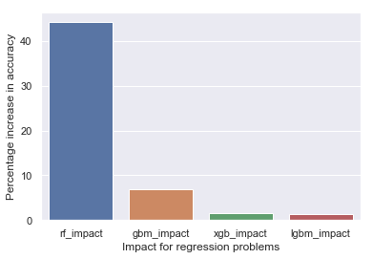
Fig. 4.4

Fig.4.5 and Fig.4.6 shows the overall impact of ensemble models considering Linear model / Logistic model for classification and regression problems respectively. In order to calculate the overall consolidated impact of algorithms, the mean of the percentage increase of accuracy is considered which is visible in Fig 4.3 and Fig 4.4. The calculation for this procedure is as follows:
- Accuracy of [N]th model * mean of [N+1]st model accuracy.
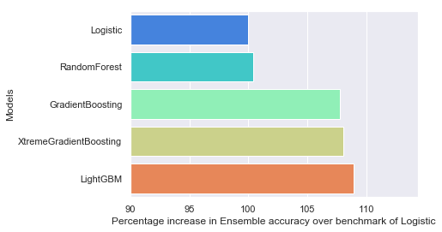
Fig. 4.5

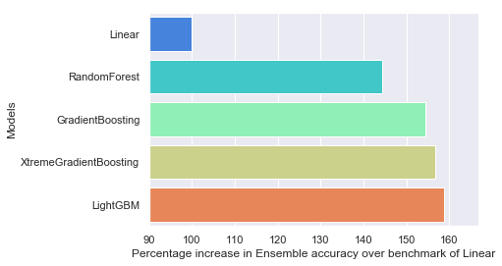
Fig. 4.6

As visible in graphs, the maximum increase in classification and regression models is brought by Gradient Boosting Method and RandomForest respectively.

Limitations & Outlook

The total number of datasets used to understand the impact of individual models is not sufficient enough to derive relations between the stated algorithms. Other variables like dataset size, variance of dataset, standard deviation of variables, etc. can be utilized to find the relation between the algorithms. The entire exercise has to be repeated on multiple datasets varying in various aspects, in order to come to a concrete conclusion. The impact was calculated basis basic models; the overall number of ensemble models can be decreased and relation between high end algorithms can be identified as well.

References

[1] A comparison of random forests, boosting and support vector machines for genomic selection

[2] Comparison of 14 different families of classification algorithms on 115 binary datasets

